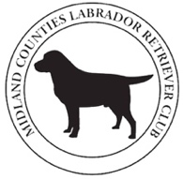

MIDLAND COUNTIES
LABRADOR RETRIEVER CLUB

SCHEDULE OF A.V. RETRIEVER 2 DAY OPEN FIELD TRIAL
(held under Kennel Club Limited Rules and Regulations ‘J’)

To be held at Lakeside Shoot, Tregynon, Powys.
By kind permission of James & Wendy Shearer & family.

Directions, timings and full details for the meet will be provided with the results of the draw.

Wednesday 3rd and Thursday 4th December 2025

STAKE: Open Stake – 24 dogs

JUDGES: John Yarwood (A3484), Richard Beckerleg (A2812), Keith Broomfield (A2214)
and Paul Stogden (B3661)

FEES: Admin Fee - £5 per dog. Entry Fee £90 per dog (member), £105 per dog (non-member).

PRIZES: Trophies TBC. Skinners vouchers & Sporting Saint gift bags for 1st to 4th places, rosettes and CoMs.
ENTRIES Tuesday 18th November 2025 at 23.59, whether via FTMS or by post (in hand, not postmark).
CLOSE:

ENTRIES TO: Jo Wilde, Field Trial Secretary, 2 Pilgrim Cottages, Longville, Much Wenlock, TF13 6FH
mclrc.ftsec@gmail.com
07774 259177

DRAW: The draw will take place by FTMS at 20.00 on Wednesday 19th November 2025. Entrants will be notified of the results of the draw by e-mail. FTMS entrants successful in the ballot must pay online before 9pm on 26th November or they will be taken out of the draw – reminders will not be sent.

DEFINITION: A stake in which dogs have the opportunity of gaining a qualification towards the title of Field Trial Champion and to entry into the Championship. It may be limited to a prescribed number of runners (J4 refers) in which case, these shall be decided by a draw conducted in accordance with regulation J6 (i) and J6 (j).

GOING: This is essentially a driven trial, but there may be a small element of walked up on the second day if conditions dictate.

We are proud to be sponsored by Sporting Saint Gundog Training Equipment, Elite Kennel Fertility & Skinner’s Pet Foods.

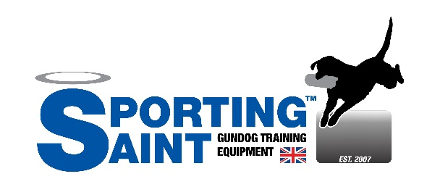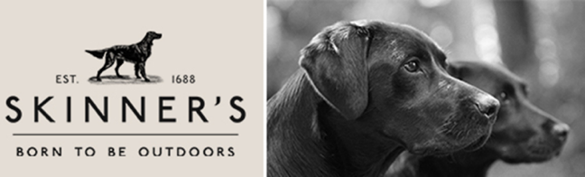
RULES AND REGULATIONS

- Dogs entered at Kennel Club Licensed Field Trials must be registered at the Kennel Club in accordance with Kennel Club Regulations for Classification and Registration B.
- The Club reserves the right to refuse entries. Competitors and spectators must always obey the red flag bearer and are required to be always of good behaviour, facilitating the smooth running of the trial and consideration of the host's property and interests.
- KC Regulation J6.f applies to those being successful in the draw but not taking up the place. Substitution for similarly qualified dogs will be allowed. Reserves will be substituted for absentees at advertised time for start of the trial. You cannot substitute the handler after the draw date.
- All dogs’ resident outside the UK must be issued with a Kennel Club Authority to Compete number before entry to the show/event can be made. All overseas entries without an Authority to Compete number will be returned to the exhibitor/competitor.
- If entries or nominations exceed the number of permitted runners, the right to compete in a Trial shall be decided by ballot.
- Should circumstances so dictate the society, in consultation with the judges, may alter arrangements as necessary. Such changes and the circumstances surrounding them will be reported to The Kennel Club.
- No modification may be made to the schedule after publication except by permission of The Kennel Club, followed by advertisement in appropriate journals if time permits before the closing of entries.
- Judges at a Trial are prohibited from entering a dog which is recorded in their ownership or part ownership.
- Videography and photography will only be permitted with the express permission of the Chief Steward and the host.
- Welfare of Dogs
An exhibitor (or competitor) whose dog is entered at a Kennel Club licensed event should take all reasonable steps to ensure the needs of their dog(s) are met and should not knowingly put their dogs’ health and welfare at risk by any action, default, omission or otherwise. A breach of this Regulation may be referred to the Board for disciplinary action under Kennel Club Rules and Regulations.
- The use of pinch collars, electronic shock collars, or prong collars, is not permitted at any field trial licensed by the Kennel Club. This shall apply at the venue or within the precincts of the trial.
- DOGS IN CARS ON HOT DAYS
Your dog is vulnerable and AT RISK if left in a vehicle in high temperatures and even on days considered as slightly warm. Please take care of your dog(s). If your dog is found to be at risk forcible entry to your vehicle may be necessary without liability for any damage caused.
- The running order of the stake will be in the order of the draw.
- All entries must either be via FTMS or post. Postal entries must supply a SAE for each Trial entered, to receive a copy of the draw. A copy of the draw will be e-mailed to the registered e-mail address on FTMS, it will also be available on FTMS.
- Entries must be in the hands of the Field Trial Secretary by the date shown on the schedule. Anyone unable to run must notify the Field Trial Secretary by e-mail, telephone or text message.
- There will be a refund of entry fees, less expenses incurred by the Club, if the trial is cancelled. Administration fees are non-refundable under any circumstances.
- The Midland Counties Labrador Retriever Club recommends that all dogs running should be protected against parvo virus and other contagious diseases. No bitch in season nor any dog suffering from a contagious disease will be permitted to run and must be removed forthwith.
- Competitors should report to the Chief Steward 15 minutes before the time for the start of the trial.
- The Trial will be deemed to have commenced when announced by the Chief Steward; when all competing dogs and handlers must be present.
- Only competing dogs or those fulfilling some official activity will be allowed onto the trial ground. All persons are to check with the Chief Steward before exercising their dogs.
- Unless otherwise stated trophies are kept at the joint responsibility of the winners and the Club for one year. The winner will be responsible for engraving the trophy and for its return to the Field Trial Secretary before the next succeeding Field Trial.
- All persons attending the trial do so at their own risk.
- LATE PAYMENT OF ENTRY FEES – FTMS entries successful in the ballot must pay online before 9pm on 26th November or they will be taken out of the draw – reminders will not be sent.

Please return 2024 Trophies (clean and in good order!) as soon as possible to the Field Trial Secretary.

